October 29 – November 2, 2018

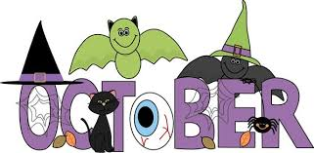

**Ms. Pettyjohn’s**

**4th Grade Math**

**Classroom News!**



**Birthday’s:**

-Ashley

-Michelle

**This Week’s Skills:**

MATH – Students will…

-Begin working with fractions

-Learn what equivalent fractions are

-Learn how to simplify fractions

-Learn how to compare fractions

-Learn how to find common denominators

-Learn how to add and subtract fractions

Then we will move into…

-Mixed numbers

-Proper and Improper fractions

**Homework:**

**Monday:** Equivalent Fractions Worksheet

**Tuesday:** Adding Fractions Worksheet

**Wednesday:** NO HOMEWORK – HAPPY HALLOWEEN!!!

**Thursday:** Subtracting Fractions Worksheet

**Friday:** NO HOMEWORK – HAVE A GOOD WEEKEND!!

**Key Vocabulary:**

-Numerator -Common

-Denominator Denominator

-Equivalent

-Mixed number

-Proper fraction

-Improper Fraction

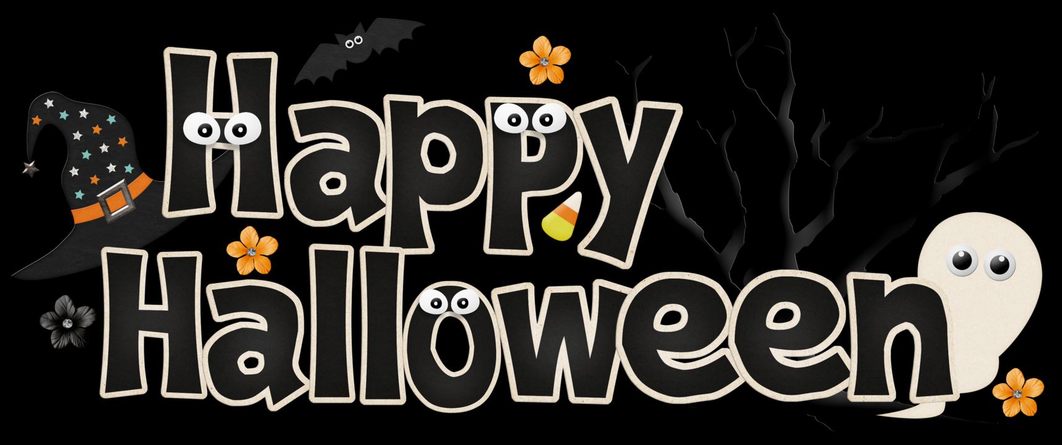

**CONTACT INFORMATION:**

*Cell: 111-222-3333

*Work Phone: 111-222-3333

*Email: kmp057@shus.edu

Have a faBOOlous Halloween!!



**Dates to Remember:**

10/31: Classroom Halloween Party – Bring treats and a trick-or-treat bag!

10/31: HAPPY HALLOWEEN!!!